11 Estates Microsite Generator

Objective
Build a system that allows the 11 Estates team to create project microsites without coding.
The reference for the website structure is the Propsoch project page (link below).
The goal is to replicate the overall layout, navigation, and user experience while replacing Propsoch branding and removing sections that are not relevant to 11 Estates.

Website Structure
Look at this sample website link

https://www.propsoch.com/property-for-sale-in/bengaluru/casagrand-casablanca-kanakapura-road/355

This is my inspiration page. I need exactly like this

The website header gets replaced with 11estates website header from core website

Subheader onwards is where my project microwebsite begins

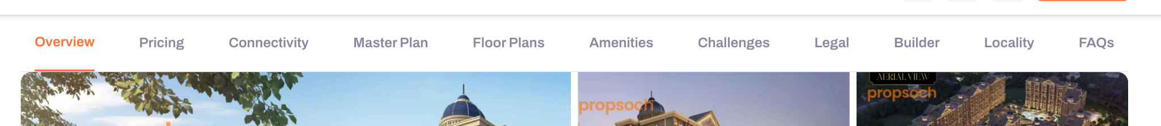

Section Navigation Bar
Keep the secondary sticky navigation bar from the reference page. Keep all options except for Challenges and property trend
Use the same concept and scrolling behavior.
Users should be able to click any section and jump directly to it.

Required design change
The top of the page in my mind should be
header,
subheader and
the project name/summary (name, builder, location, price range, possession date, config and builder logo)
with a card on the right. And we ensure the card on the right is there throughout the page scrolling.
The images will be between the project name/summary and the Overview section. So image layout might have to change.
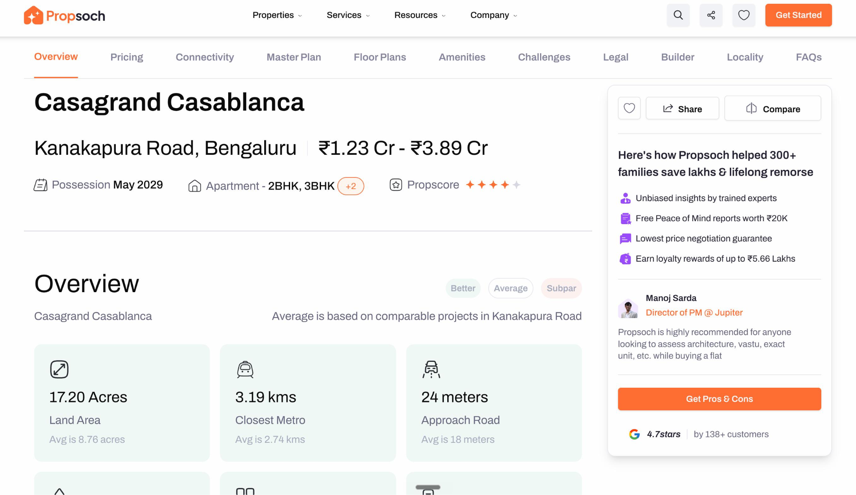

Inquiry Form/Sticky card content
Replace the sticky Propsoch information card on the right side with a sticky inquiry form.
The form should remain visible while the user scrolls.
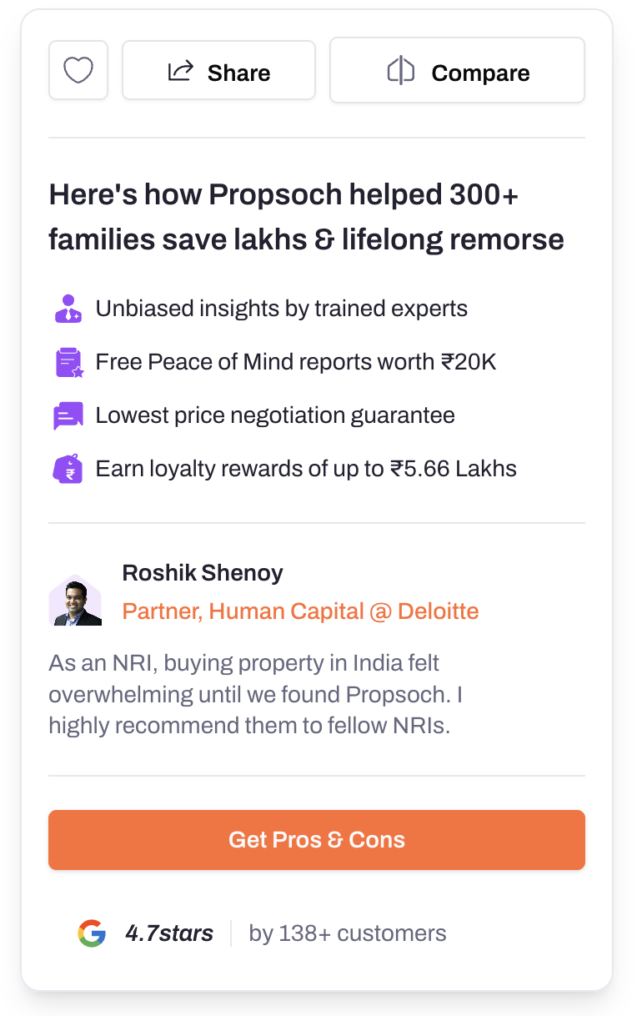

Why Homebuyers Work With 11Estates
You pay nothing. We represent your interests. We negotiate with builders on your behalf.
✓ No Brokerage, No Service Fees
✓ Best negotiated price
✓ Expert Guidance from Search To Purchase
Speak with an advisor before you commit to a unit.
Name*
Mobile Number*
Email
Submit Button

Sections to Remove
Remove the following sections from the reference page:
- Challenges
- Price Trend Chart section
- Anywhere there is Propsoch marketing like their founder video
Everything else can remain structurally similar to the reference page.

FAQ Section
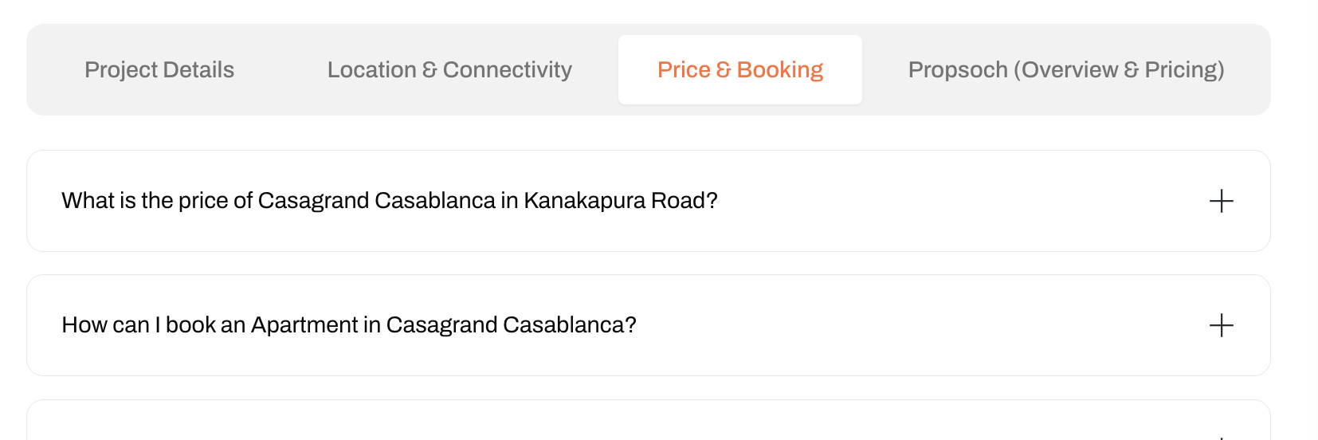
There is a 4th tab in FAQ section we will replace 4th tab propsoch with 11estates
With some Q&A related to us (need to think content)

Microsite Generator
The team should not create pages manually.
Instead, there should be a "Create Project" option in the admin panel.
When clicked, a form should open.
The form should contain all information required to populate the microsite inspired from the propsoch page.
There should be fields for all these areas. Some fields will have text content, some will have image upload option
The idea is simple:
Every section visible on the website should have a corresponding field in the project creation form.
Examples:

Basic Information
- Project Name
- Builder Name
- Location
- Possession Date
- Project Description

Pricing
- Configuration
- Area
- Price

Connectivity
- Connectivity points
- Distances
- Travel times

Uploads
- Hero Images
- Gallery Images
- Master Plan
- Floor Plans
- Builder Logo
- Brochure PDF

Builder Information
- Builder Description
- Builder Details

FAQs
- Question
- Answer

Workflow
- Create Project
- Fill Form
- Upload Assets
- Save Draft
- Preview Website
- Publish Website
The team should be able to review the microsite before it goes live.

URL Structure
Projects should be published in a structured format. May be one of the questions on the extrement start of the microwebsite form is (what is the builder name, what will be the project name for URL, as sometimes we will only mention /lodha-marquis, sometimes we will call it /prive-bandra
Examples:
11estates.in/lodha/lodha-marquis
11estates.in/godrej/godrej-riverine
11estates.in/prestige/prestige-ocean-towers
This structure should be followed from the beginning so projects remain organized as the business grows.

Data backend
Each project website will have a contact form, we need to capture info of people who showed interest. Google sheet is fine (Open to airtable if there is no learning curve and free)
Someway can we track on which project client showed interest. Only if it is easily possible, can each contact form have a unique ID in the backend so that we know for which project the enquiry is coming from. That makes telecalling easier, because when we call and we say that we saw your interest for Rustam ji pre-wake, that makes a better impression compared to brokers today, where they call and say we saw your interest.

